|  |  |  |  |  |  |  |
| --- | --- | --- | --- | --- | --- | --- |
| logo-UMP2 | **FACULTY OF COMPUTER SYSTEMS & SOFTWARE ENGINEERING** | | | | | **MARKS**:  /10 |
| **COURSE:** Database Systems | | **CODE:** BCI2023 | | |
| **TOPIC: Create Table** | | | | |
| **ASSESSMENT:** Lab Sheet | **NUM: 1** | | | **DURATION:** 2 hours |
|  | | | | | | |
| **MATRIC NUM**: _______________________________ | | | | **IC NUM: ________________________________** | | |

**CREATE TABLE**

**PURPOSE:**

**To create a table, the basic structures to hold user data, specifying this information are:**

* **column definitions**
* **integrity constraints**
* **the table's tablespace**
* **storage characteristics**
* **an optional cluster**
* **data from an arbitrary query**

**SYNTAX:**

**CREATE TABLE [schema.]table   
          ( { column datatype [DEFAULT expr] [column_constraint] ...   
            | table_constraint}   
         [, { column datatype [DEFAULT expr] [column_constraint] ...   
            | table_constraint} ]...)   
         [AS subquery]**

**Where:**

* **schema : is the schema containing the table. If you omit schema, Oracle assumes the table is in your own schema.**
* **table : is the name of the table to be created.**
* **column : specifies the name of a column of the table. The number of columns in a table can range from 1 to 254.**
* **datatype : is the datatype of a column.**
* **DEFAULT : specifies a value to be assigned to the column if a subsequent INSERT statement omits a value for the column. The datatype of the expression must match the datatype of the column. A DEFAULT expression cannot contain references to other columns, the pseudocolumns CURRVAL, NEXTVAL, LEVEL, and ROWNUM, or date constants that are not fully specified.**
* **column_constraint : defines an integrity constraint as part of the column definition.**
* **table_constraint : defines an integrity constraint as part of the table definition.**
* **AS subquery : inserts the rows returned by the subquery into the table upon its creation. If you include this clause, the column definitions can only specify column names, default values, and integrity constraints, not datatypes. Oracle derives column datatypes and lengths from the subquery. Oracle also automatically defines NOT NULL constraints on columns in the new table if they existed on the corresponding columns of the selected table and the subquery does not modify the column value with a SQL function or operator. A CREATE TABLE statement cannot contain both the AS clause and a referential integrity constraint definition.   
  The number of columns must equal the number of expressions in the subquery. If all expressions in the subquery are columns, you can omit the columns from the table definition entirely. In this case, the names of the columns of table are the same as the columns in the subquery.**

**PREREQUISITES:**

**To create a table in your own schema, you must have CREATE TABLE system privilege. To create a table in another user's schema, you must have CREATE ANY TABLE system privilege. Also, the owner of the schema to contain the table must have either space quota on the tablespace to contain the table or UNLIMITED TABLESPACE system privilege.**

**Example:**

**A Student table, enter:**

**SQL> CREATE TABLE Student**

**( Name VARCHAR2(30),**

**StudentNumberNUMBER(4),**

**Class NUMBER(4),**

**Major VARCHAR2(4)**

**);**

**Table created.**

**A Student table with constraint, enter:**

**SQL> CREATE TABLE Student**

**( Name VARCHAR2(30),**

**StudentNumberNUMBER(4) NOT NULL,**

**Class NUMBER(4),**

**Major VARCHAR2(4),**

**Primary key (StudentNumber)**

**);**

**EXERCISE. Write SQL statement for the following Table**

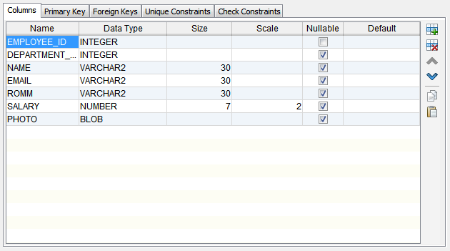

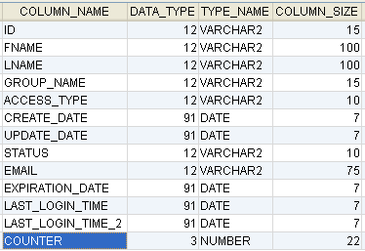

**CREATE TABLE STAFF**

**(STAFF_ID VARCHAR2(12),**

**STAFF_FNAME VARCHAR2(12),**

**STAFF_LNAME VARCHAR2(12),**

**GROUP_NAME VARCHAR2(12),**

**STAFF_ACCESS_TYPE VARCHAR2(12),**

**CREATE_DATE DATE,**

**UPDATE_DATE DATE,**

**STATUS VARCHAR2 (12),**

**EMAIL VARCHAR2(12),**

**EXPIRATION_DATE DATE,**

**LAST_LOGIN_TIME DATE,**

**LAST_LOGIN_TIME_2 DATE,**

**COUNTER NUMBER(3));**